2019 Year 11 Mathematics Methods

INVESTIGATION 1: Transformations

Calculator Assumed

TAKE HOME SECTION

# NAME: _________________________________________ TEACHER: ____________________________________________ DUE DATE: Friday 15 March 2019

INSTRUCTIONS:

Complete this take home section BEFORE the in-class validation on the morning of Friday 15 March.

You may bring your ClassPad and this take home section with you for the validation. You will have access to this take home and your work in the validation.

This page has been left blank intentionally.

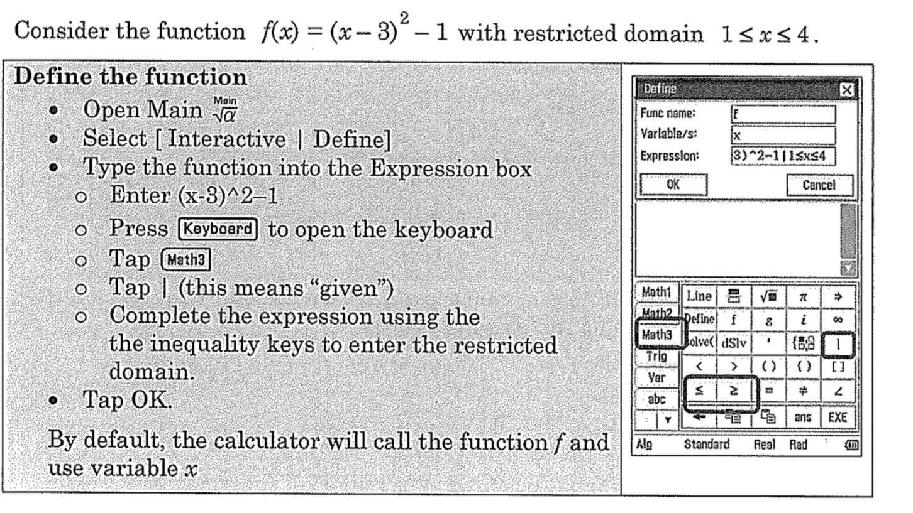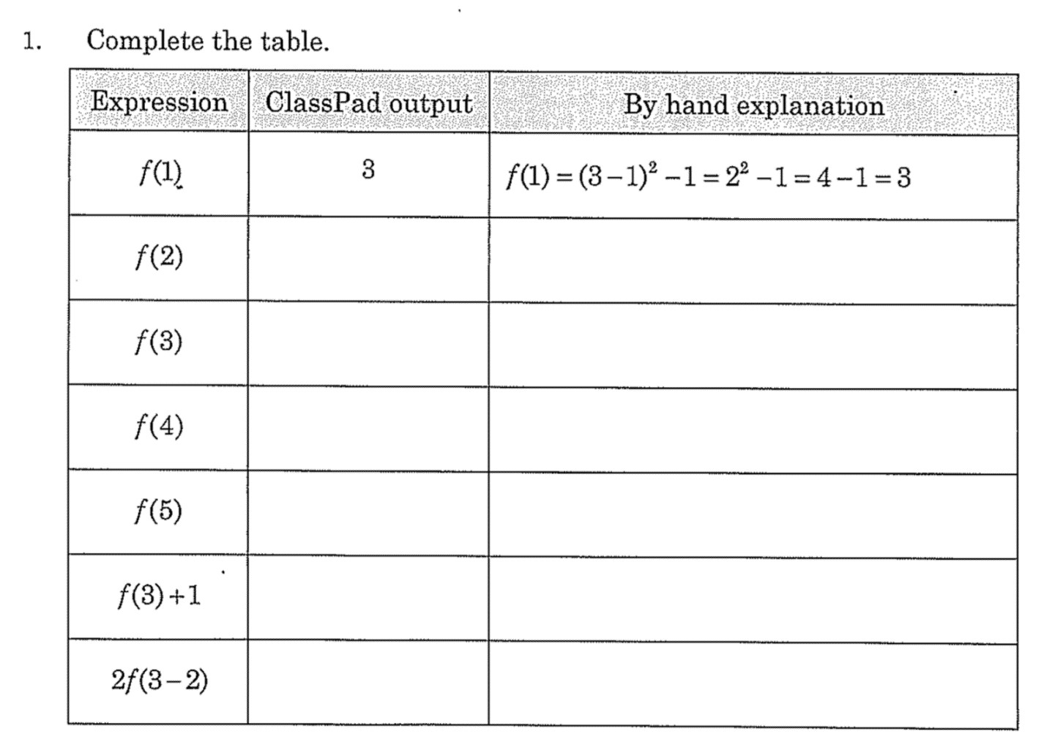

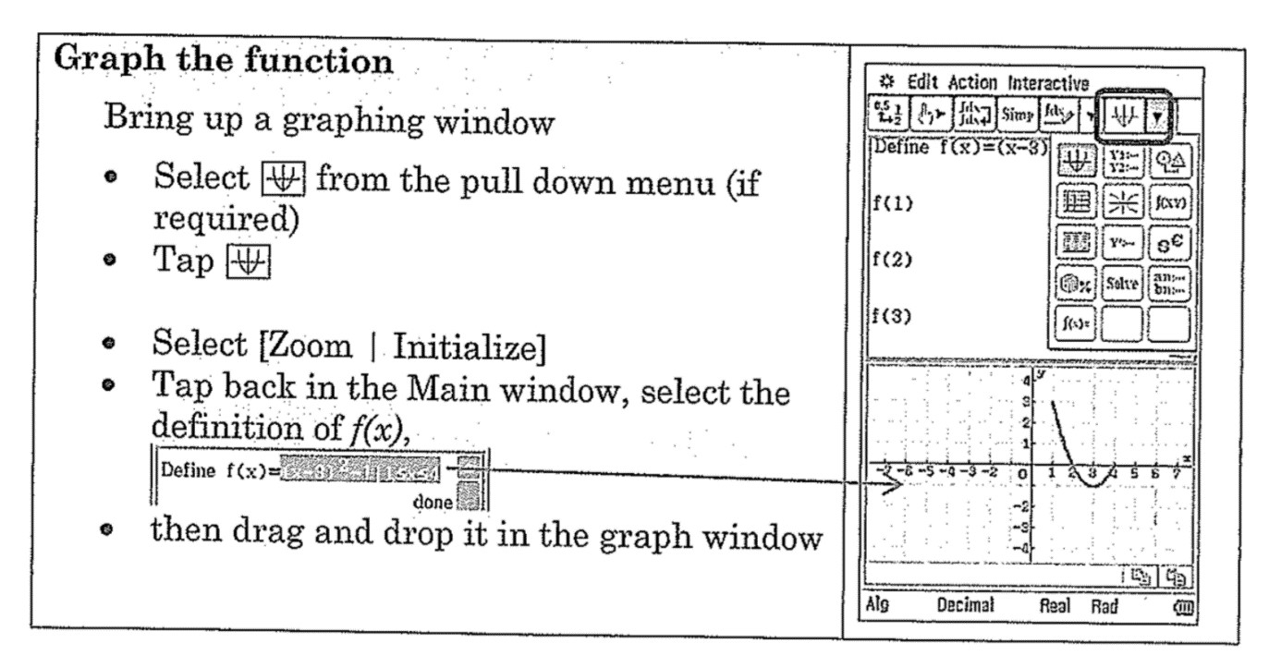

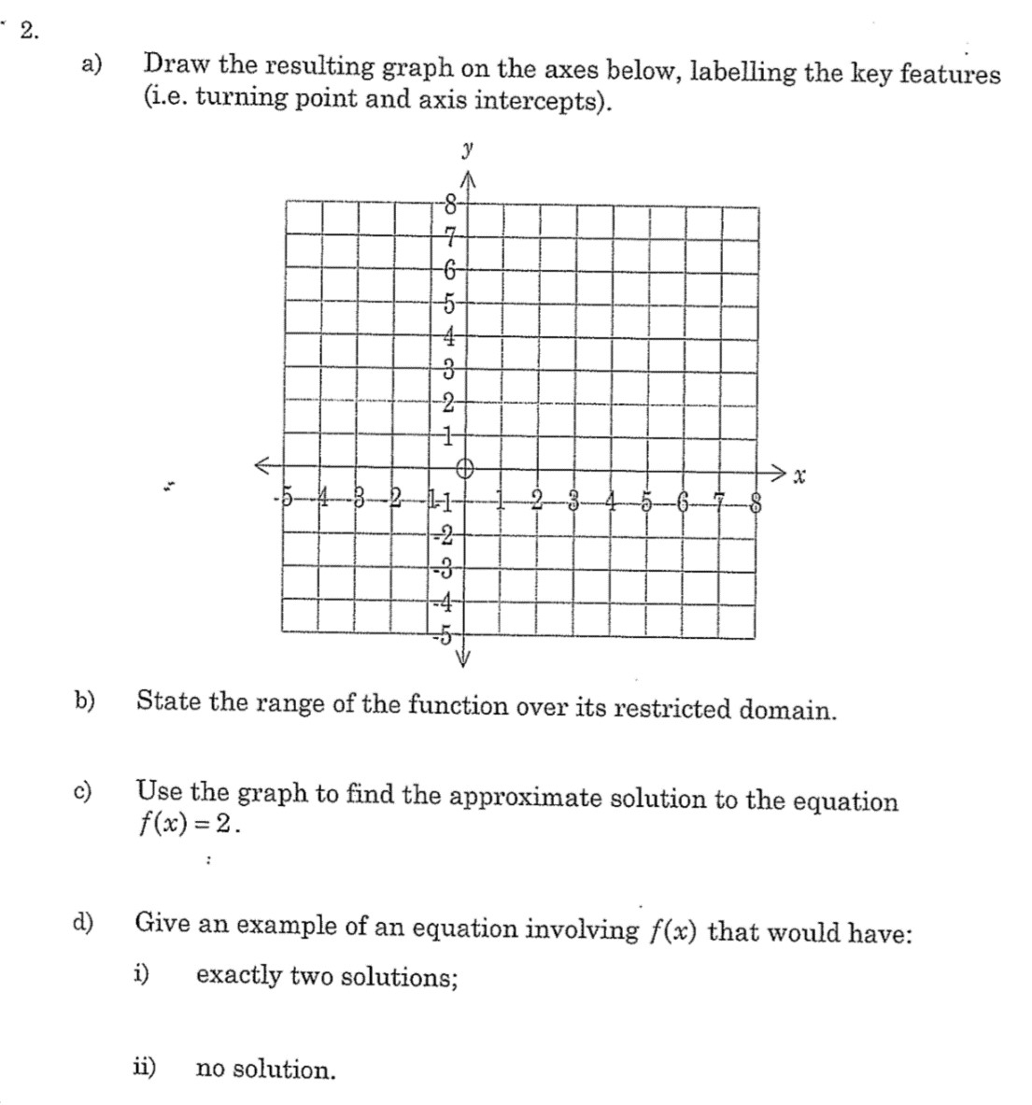

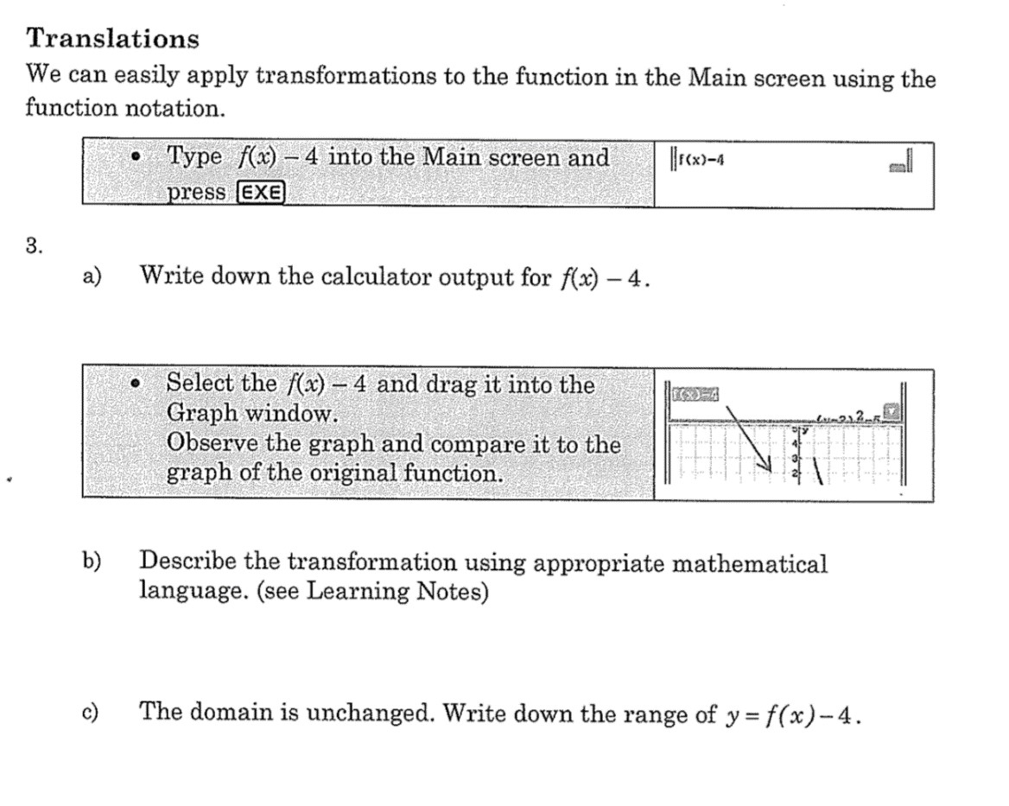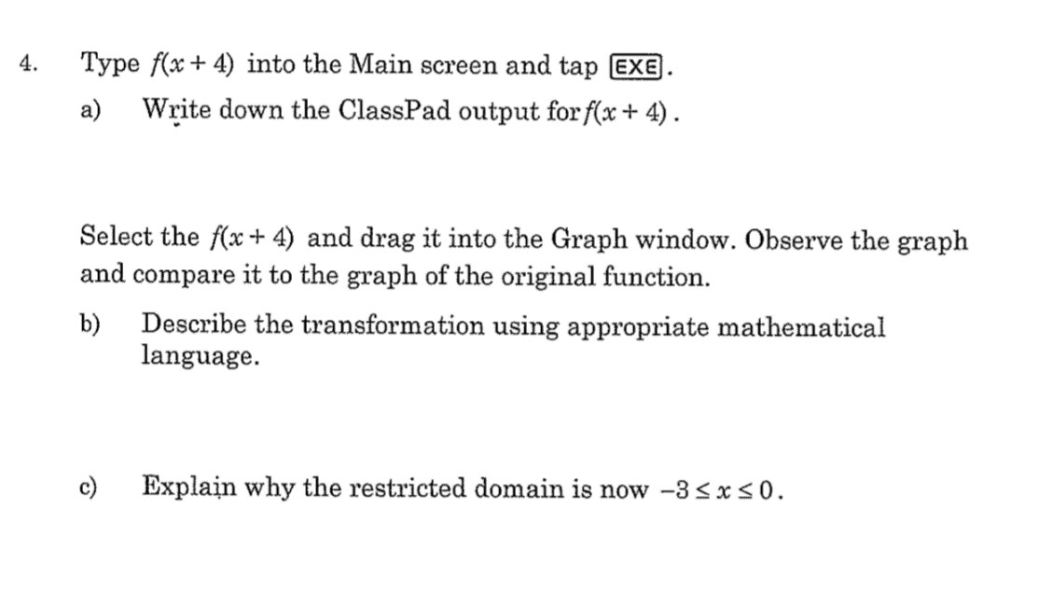

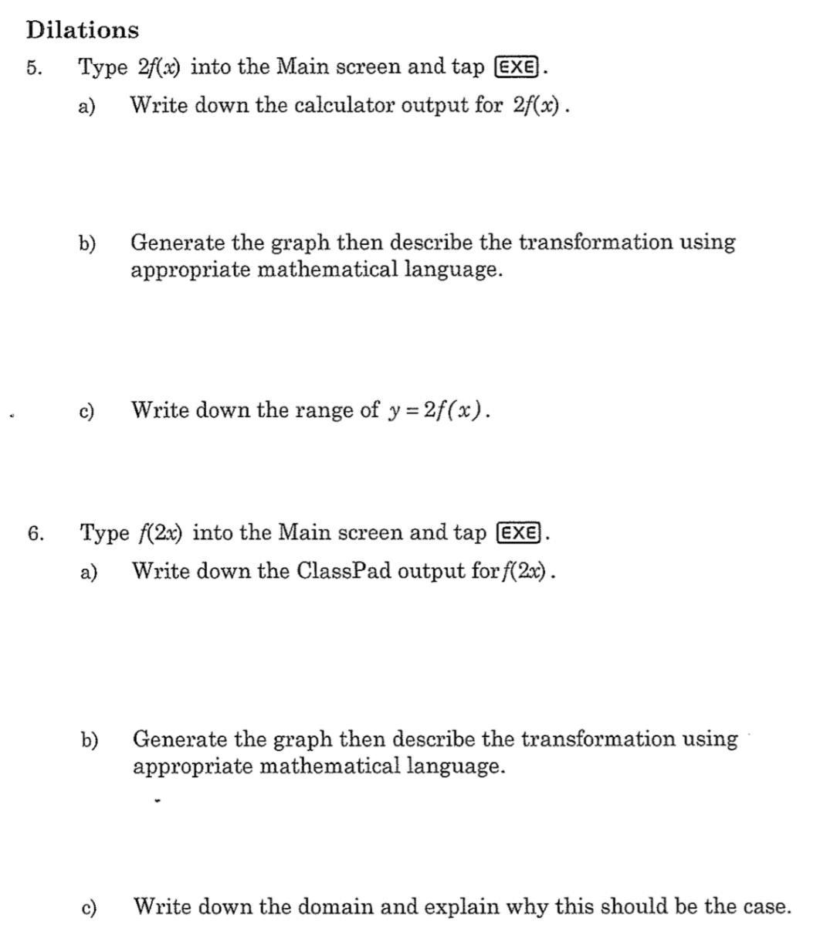

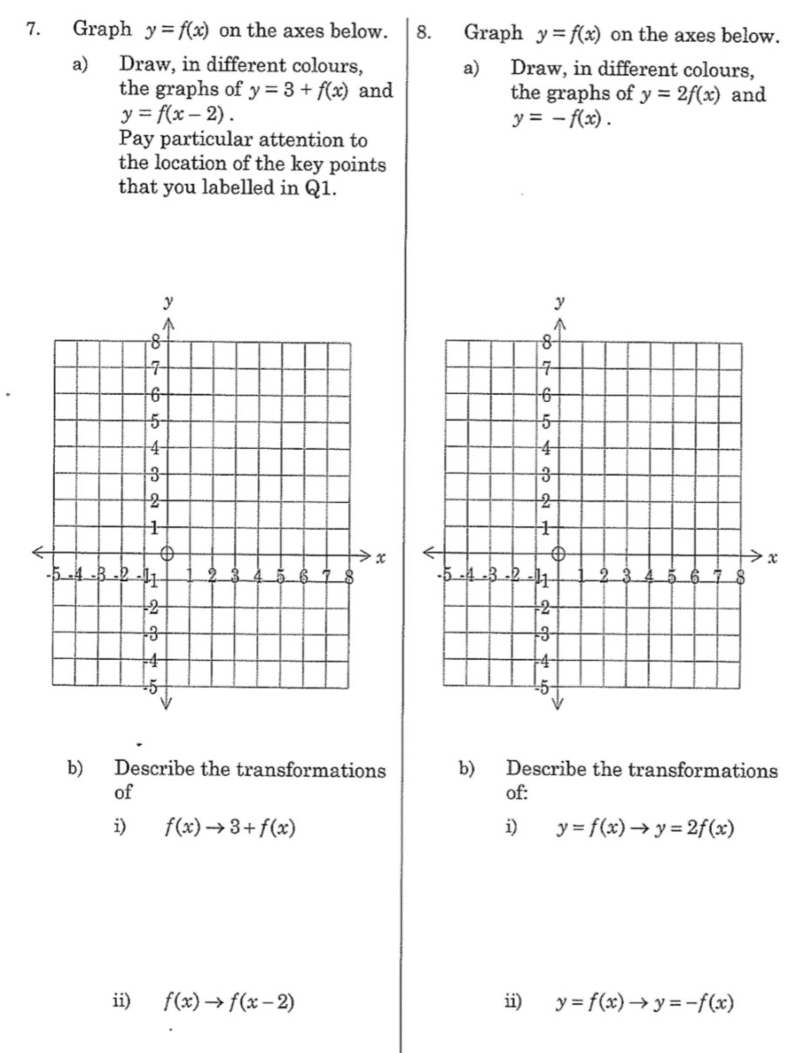

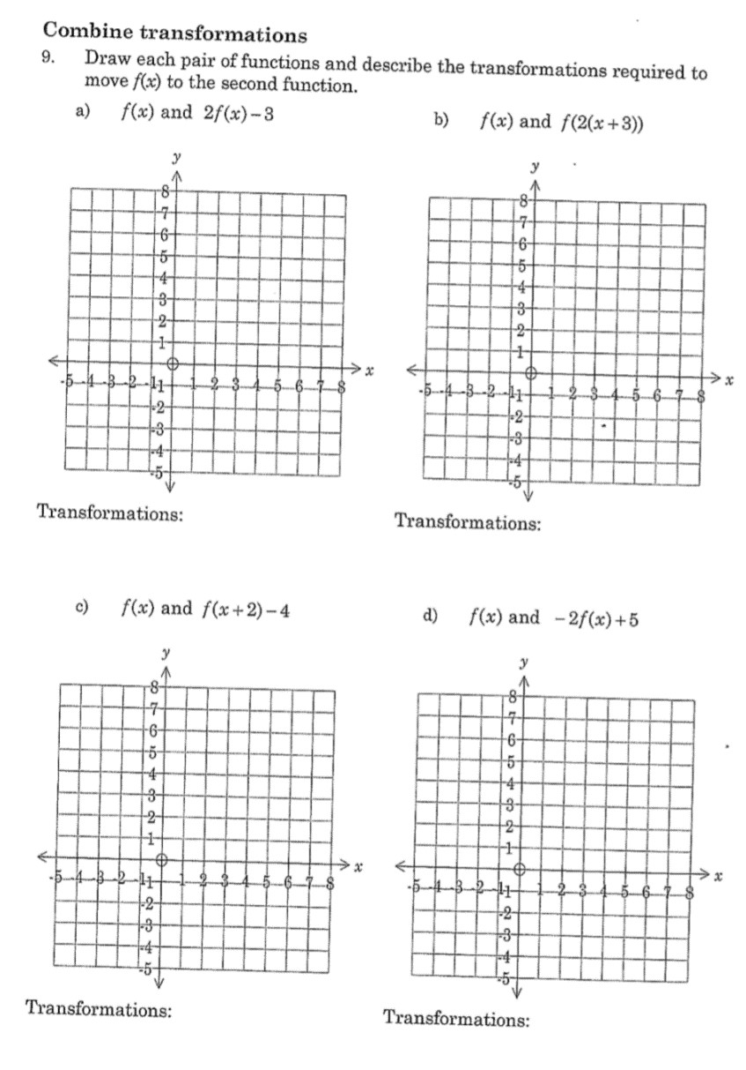

**Modelling with Transformations**

10. Using the transformations of functions we are able to model real world objects. This is useful in modern engineering to simulate and test designs before starting expensive

In this exercise we will use the Voyage 1 spacecraft as an example. This space craft was launched by NASA in 1977 and in 2012 become the first human built object to pass the Heliopause and move into interstellar space. It is expected that Voyage 1 will continue to provide scientific data until 2025.

building processes.

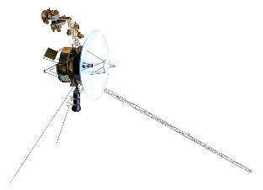

One of the defining features of Voyager 1 is the large parabolic

reflector dish mounted on it. This dish is part of the communications system and supports the extreme long range communication.

Given the parabolic dish has a diameter of 3.66 meters and depth of 0.8 meters (use these values for this exercise).

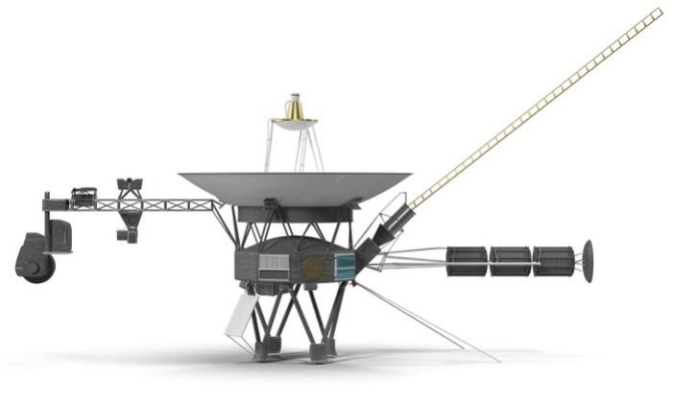

For the function that represents the Reflector Dish, as shown on the graph on the previous page.

1. State the coordinate of all intercepts.

1. State the coordinate of the vertex for the Reflector Dish Function

Use the turning point form :𝒚=𝒂(𝒙−𝒉)𝟐+𝒌

1. Calculate **a** (to 4 decimal places)

1. If 𝑓(𝑥) =𝑥2, State the transformations required to make f(x) transform into the Reflector Dish Function.

1. State the Reflector Dish function in terms of f(x)